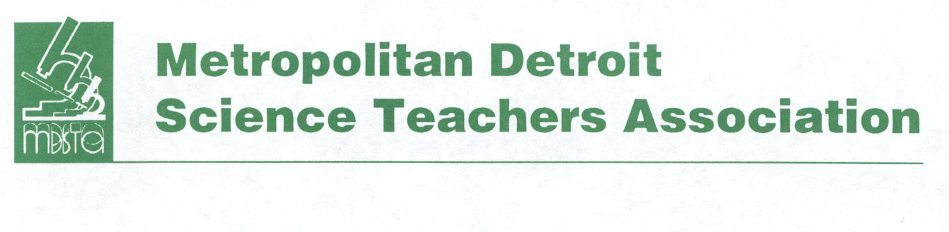

MDSTA Mini-Grant Application Form

The Metropolitan Detroit Science Teachers Association provides mini-grants to members for innovative and exciting science projects or programs.

Eligibility – You must be a current member of the MDSTA and be assigned at least 50% as a classroom teacher. You are not eligible if you have received an MDSTA mini-grant in the past two years. Current members of the MDSTA Board of Directors are not eligible.

Mini-grants are awarded for amounts up to $500.00. The mini-grant is to be used during the following school year.

Please write a one page project proposal which includes the following: purpose/statement of need, description of the activity, timeline of activity, description of how the activity will be assessed, a brief itemized budget, number of students impacted and grade level(s). Writing should be proof-read before submission and essentially error-free in grammar, spelling, punctuation, sentence structure, etc.

A committee of the MDSTA Board will determine grant winner(s) in February. Winner(s) will be notified in March. Winner(s) are required to submit an article and photos related to the project upon completion to be featured in the newsletter and they will be required to present their project at the general membership meeting in May and at the annual MDSTA Fall Conference.

Name of your Project or Proposal ____________________________________________________________

Amount of request $___________ Date submitted _____________________________

Name __________________________________________________________________________________

Home Address ___________________________________________________________________________

City ______________________________________________________ State _______ Zip _____________

Home phone ___________________________ E-mail __________________________________________

School name __________________________________ School District _____________________________

This form together with your one page proposal constitutes a complete application.

All completed applications must be emailed or postmarked by January 31st

Please send proposal and completed form to: MDSTA, Att: Mini-grant, P.O. Box 111, Southfield, MI 48037 or email to mdsta1941@gmail.com

Questions? Contact Debby Peters at 248.642.6326 or djapeters@gmail.com

Purpose/Statement of Need

Clearly explain the purpose of your project. What problem will this grant solve or need will this grant address?

Activities

Outline the activities you’re going to do that will address the purpose of your project. Individuals involved, start and completion dates, ect.

Project Assessment

How are you going to evaluate the success of this project? How will you determine if the problem was solved, need was met or objective mastered?

Budget

Write a budget outline for the project. Chart, table or list should include the following information: Item, Quantity, Item Amount, Sub Total and Total ex. supplies, equipment, bus etc.

Number of Students Impacted Grade Level(s) of Students

